**Case Study / Scenario:-**

You are working for a software house who has a small and medium-sized enterprise (SME) customer that provides specific digital products to its clients. Your line-manager sent you a request to develop a simple client registration program in order to store clients’ detail, such as Client ID, Name, Address, Phone number, Email, and 5 categories based on the client’s selected products (Software, Laptops & PC, Games, Office Tools, and Accessories). As part of the software development team, you are going to develop a client registration system (CRS) that should have the following functions (options):

1. Add (enroll) new client details/record.

2. Search for any client details. (You can use Client ID as a primary key)

3. Remove any client including all the client details.

4. Print all the client’s details.

5. Order the stored clients based on their names.

6. Save the clients’ details into the file.

**Task 01:-**As a Lead Programmer for the software development team, you should produce a report, which explains the software development basic principles of the client registration system. The report should have the following:

**Part 1:** The definition of algorithm that outlines the process in developing the software application from the feasibility study stage up to the execution stage. You could further provide detailed steps from the execution stage with writing code and the program comments.

**Algorithm:**

Step 1: Determine the goal of the **algorithm**.

Step 2: Access historic and current data.

Step 3: Choose the right models.

Step 4: Fine tuning.

Step 5: Visualize your results.

Step 6: Running your **algorithm** continuously.

**Part 2:** Based on the scenario, you should provide an algorithm of the CRS to be developed. While making an implementation of your developed algorithm using Python programming language. You should include in the explanation of the implementation, the relationship between the algorithm and your Python code.

**Task 02:-**To ensure that your report includes set of findings and key contributions from researching the characteristics of different programming paradigms; procedural, event driven and objectoriented programming for the team to understand, how to develop a secured program. Further, it is important to compare the procedural, event driven and object orientated paradigms with relevant source code examples. The report, on the programming paradigms, should also include an evaluation of your Python code related to different programming paradigms according to its code structure and characteristics.

**Relation Between Python Code and Algorithm:**

Step 1: Look for the goals of Python programs.

Step 2: Access current data available.

Step 3: Choose the right modules inn Python language.

Step 4: Start Coding Your Task.

Step 5: Make logic of every step and visualize results.

Step 6: Debug you code.

**Task 03:-** To support other team members to use the developed application including Python program by producing your software application in the form of a portfolio to help them understand the whole software development process. Further, it is expected that you implement the defined algorithm into a functional Python program using any IDE of your choice and illustrate the outputs using screenshots and executional file. Your report should include evaluations of developing software applications using an IDE versus non-IDEs.

**Difference Between Software Coded with IDE and with Text Editor:**

Text editors which are available in the normal Windows working environment but the use of IDE’s seem to serve the purpose which lies at hand. An editor is labelled as a tool that edits texts always getting used, but there are several differences which are consistently seen when practicing a more comprehensive process used as it lies straight with IDE’s having original programming interfaces.

Implementation of an integrated development environment has considerable advantages but when you get down to using several modes of operation with programming made in a variating mode as always is implementable. An ease in operating with text editors has a use of several and different languages which you use on this one editor but there is a use that is universal and considered helpful when you get particular inception to get programming as an enjoyable profession.

If you work with a particular IDE there are groundbreaking uses that are accepted and make concern to reduce formality having intention to get programming work under implementation. Associate through a particular editor that is used when there is no particular and given one used with a programming platform you are working with. Make use of best efforts and be assured to use a compilation tool that is a sensible solution.

**Task 04:-** Once the Python program has been developed, it is important to develop a software testing process. You have to test the functionality of the program and test procedure planning as a requirement to have a successful debugging and software testing. In view of this, you are required to produce a brief report explaining the process of debugging your program and explain the debugging facilities that are available in the choice of your IDE. You are also required to ensure that best practices and coding standards are outlined, and you have incorporated in writing the source codes using Python programming language. In your report, evaluate how debugging processes can support the development of more secure and robust software applications, and provide recommendations for the team to improve your program. Hence, it is important to make a simple critical evaluation for the basics of coding standards and its benefits to your organization. This can be used as guidance for both levels, the team (staff) level and individual (programmer) level. Note: the working application produced must also be demonstrated to the team.

**Python Code:**

# class that is representing our enterpirse software

class Enterprise:

#function to store client data

def AddClient():

fp=open("EnterpriseData.txt","wt")

name=input("Enter Client's Name: ")

id=input("Enter Client's ID: ")

address=input("Enter Client's Address: ")

phone=input("Enter Client's Phone Number: ")

category={

"1":"Software","2":"Laptop","3":"Games",

"4":"Office Tools","5":"Accessories"}

print("Catagories Available: ",category)

cat=input("Enter Catagory of User: ")

fp.writelines("Client's Data\n")

fp.write("ID: ")

fp.write(id)

fp.write("\tName: ")

fp.write(name)

fp.write("\tAddress: ")

fp.write(address)

fp.write("\tPhone: ")

fp.write(phone)

fp.write("\tCategory: ")

fp.write(cat)

fp.write("\n")

print("Client is Added in",fp.name)

fp.close()

#new client function

def AddNewClient():

fp=open("EnterpriseData.txt","a")

name=input("Enter Client's Name: ")

id=input("Enter Client's ID: ")

address=input("Enter Client's Address: ")

phone=input("Enter Client's Phone Number: ")

category={

"1":"Software","2":"Laptop","3":"Games",

"4":"Office Tools","5":"Accessories"}

print("Catagories Available: ",category)

cat=input("Enter Catagory of User: ")

fp.writelines("Client's Data\n")

fp.write("ID: ")

fp.write(id)

fp.write("\tName: ")

fp.write(name)

fp.write("\tAddress: ")

fp.write(address)

fp.write("\tPhone: ")

fp.write(phone)

fp.write("\tCategory: ")

fp.write(cat)

fp.write("\n")

print("Client is Added in",fp.name)

fp.close()

#search client function

def SearchClient():

id=int(input("Enter Client's ID to Search: "))

name=input("Enter Client's Name to Search: ")

#reading content of file

fp=open("EnterpriseData.txt","rt")

data=fp.readlines()

if id==data and name==data:

print("This Client is Present in File!")

else:

print("This Client is not Present in File!")

#remove client function

def RemoveClient():

with open("EnterpriseData.txt","rt") as fp:

data=fp.readlines()

with open("EnterpriseData.txt","wt") as fp:

print("Deloeting Clients Data is Present in File!")

for line in data:

if line.strip('\n')!="ID: 190820":

fp.write(line)

print("Clients Data is Deleted!")

def PrintDetails():

print("Displaying Client's Data")

with open("EnterpriseData.txt","r") as fp:

data=fp.readlines()

print(data)

#function to display menu

def Menu():

print("||====================================||")

print("|| Enterpise System ||")

print("||====================================||")

print("||1. Add Client Data ||")

print("||2. Add New Client Data ||")

print("||3. Search for Client ||")

print("||4. Remove Data of File ||")

print("||5. Print Details of Any Client ||")

print("||6. Save Data into Text File ||")

print("||====================================||")

#while loop take input from user

while(True):

usrinput=int(input('Enter Key to Perform Option: '))

if usrinput==1:

en=Enterprise.AddClient()

elif usrinput==2:

en=Enterprise.AddNewClient()

elif usrinput==3:

en=Enterprise.SearchClient()

elif usrinput==4:

en=Enterprise.RemoveClient()

elif usrinput==5:

en=Enterprise.PrintDetails()

elif usrinput==6:

print("Data is Already Saved at Input!")

contd=input("Do You Want to Continue(Y/N): ")

if contd=="n" or contd=="N":

print("Quitting Enterprise Software\n")

break

#calling main menu finction

Menu()

**Testing and Output:**

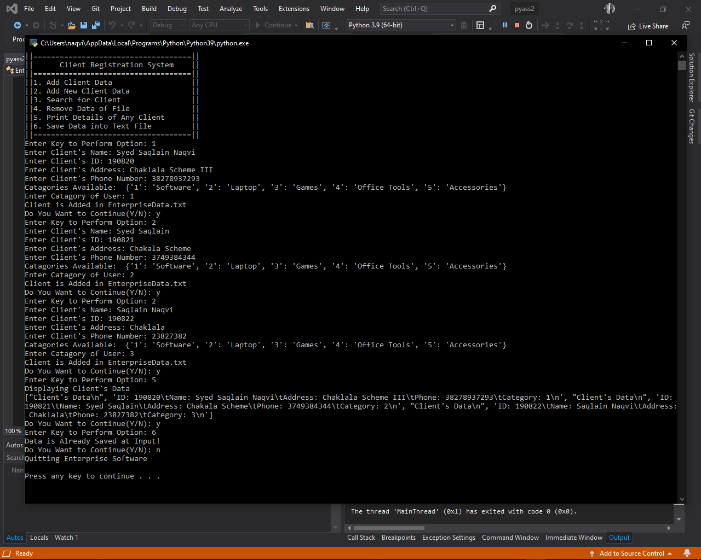

**Data Stored Premanently:**

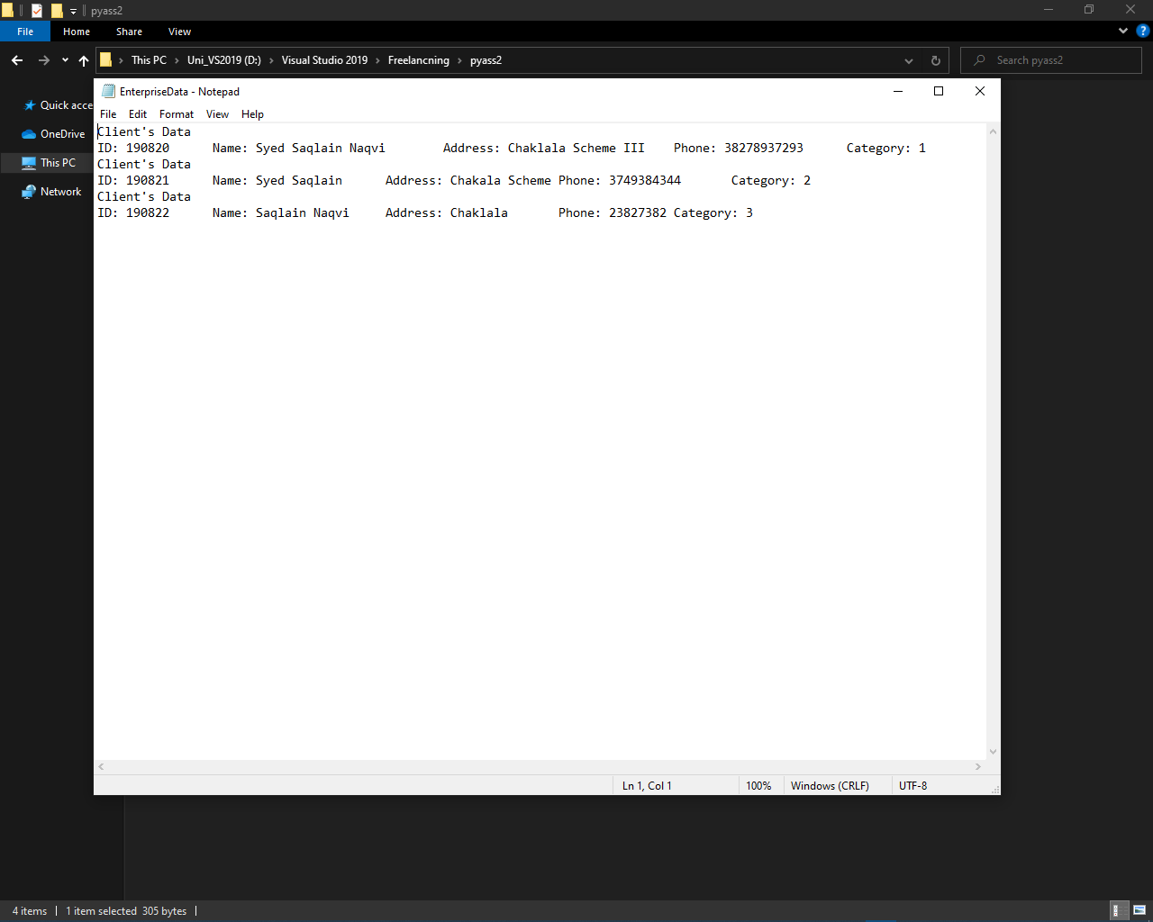

**THE END.**